Real Estate Investing With Curvy Girl  Contact Me at- reiwithcurvygirl@gmail.com or message me on Facebook @REIWithCurvyGirl to set up a FREE Coaching Call | Real Estate Investing With Curvy Girl is a labor of love, born from a need to find freedom and some semblance of joy and peace. It wasn’t my intention to be a successful Real Estate Investor and Coach. I was simply a VERY busy single mom of 2 beautiful children, slave to a career, and wanting more out of life… I feel so fortunate to have the time and what has changed my life to help people change their lives in a way that honors who they are and what they want to accomplish!
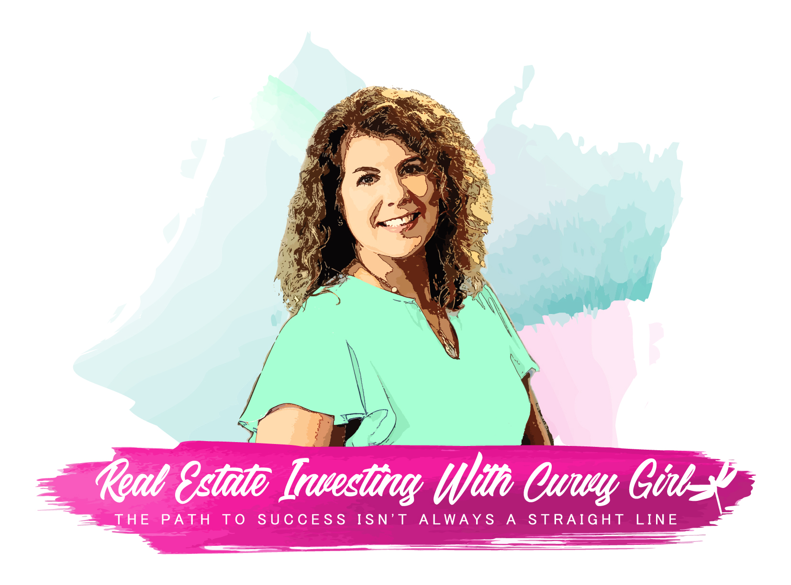 | 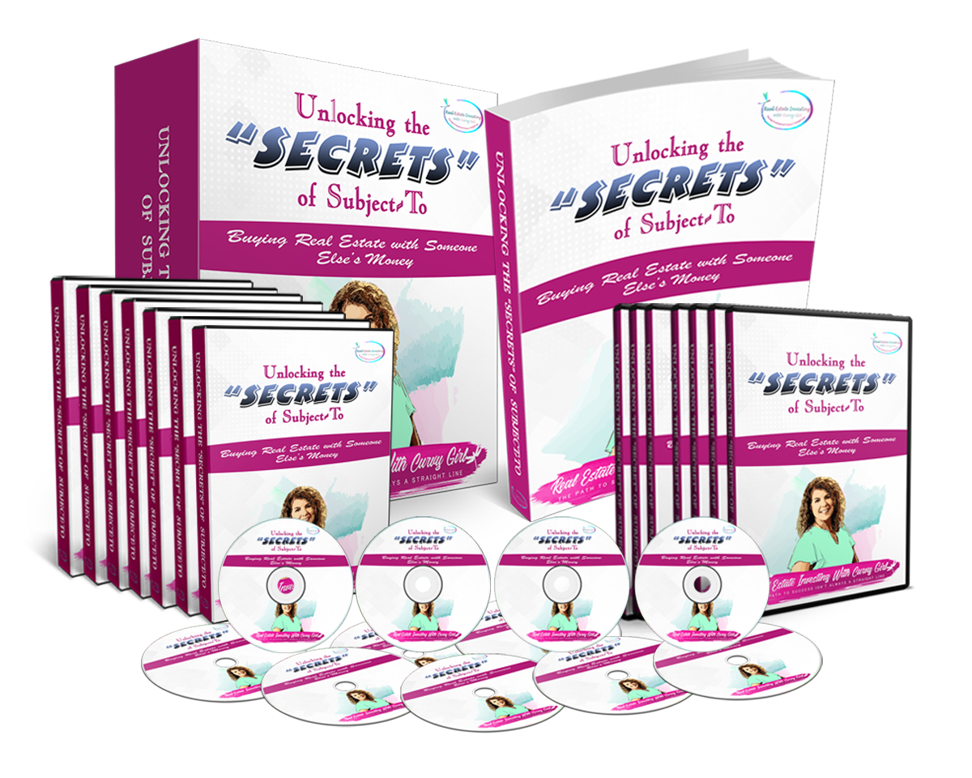

Coaching- 1:1 or Group Coaching Options
- Real Estate Investing
- Business
- Life Design
Consulting-
- Including Deal Review and Direction and MUCH More
Signature Course- “Unlocking the Secrets of Subject To”- http://bit.ly/UnlockingSubject-To
Training –
- Coaching your Tenant Buyers to Home Ownership
- Working Effectively with a Partner
- Winning Connections and Conversations
- Many More

Contact Me at- reiwithcurvygirl@gmail.com or message me on Facebook @REIWithCurvyGirl to set up a FREE Coaching Call

